Design Report

Contents

1. Heading 1 3

1.1 Heading 2 List 3

1. Chen Entity Relationship Diagram

1. Data dictionary

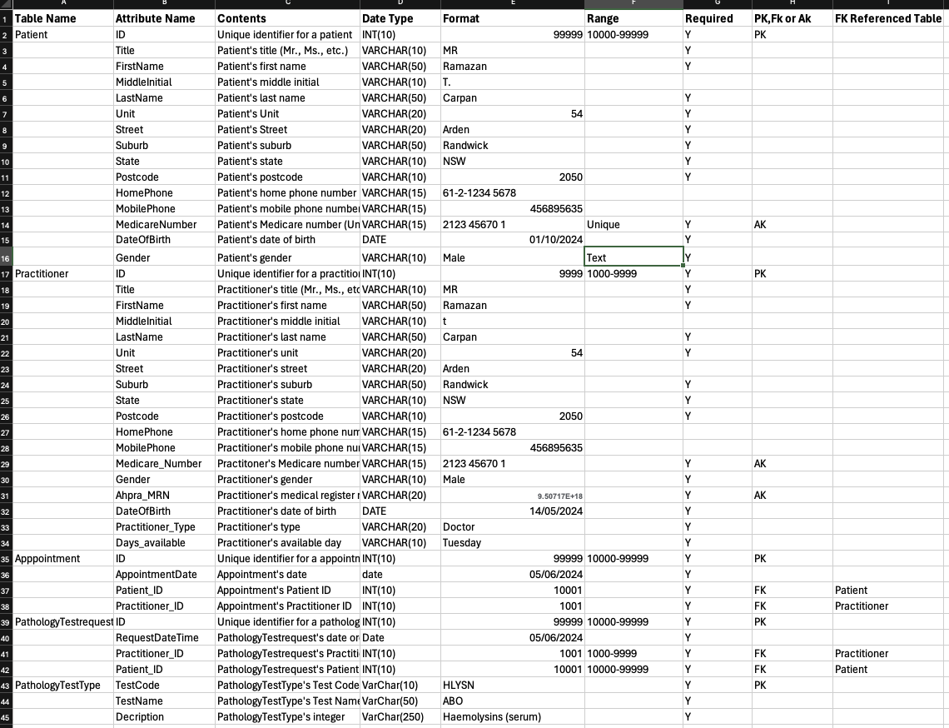

1. Crow’s Foot Entity Relationship Diagram

